AFN BASKETBALL CLUB

USER MANUAL

Presented by:

Fadi El Bejjani  
Anthony Farhat  
Nassib Khoury

Table of Contents

Abstract 3

How to Install 3

Admin 4

Guests 6

Members 8

Players 10

Coach 12

# Abstract

This document represents the Software User Manual for AFN Basketball Club and was written according to the software engineering user documentation standards.

The purpose of this user manual is to provide all the useful information to any type of user in order to help them make use of the entire functionalities of the basketball club website.

This project was developed as a part of the Software Engineering course (EECE 430) at the American University of Beirut.

# How to Install

* The user needs to place all the files that can be found in the folder “430” in the corresponding folder: \wamp\www\ or \wamp64\www (if using 64-bit version of the Wampserver).
* Setup the connection with the server by launching the WAMP server.
* The user needs to open the browser linked with the Wampserver and type in the URL address bar “localhost/430/main.html”
* This will result in displaying all the content of the main page of the website.
* The users can now make use of the system depending on their type.
* Notice: For successful installation of the python application "hello.py" which is the statistics python code, the admin mayneed to download the required python modules to run it (matplotlib,pandas,scipy,seaborn,numble,requests,etc...)

# Admin

Sign in:

After starting the system, the admin has to choose the “Admin” type so that the login page appears.

To **sign in:**

* Enter the admin’s username in the *username* space.
* Enter the admin’s password in the *password* space.

Note: There is no option to sign up as an administrator because his info is already preregistered in the database.

Once the admin is logged in into his account, he has the ability to manage the website.

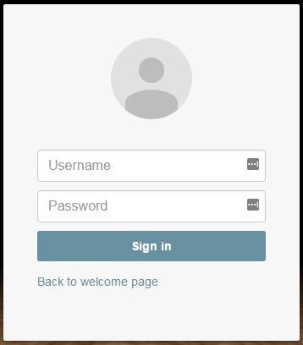

Functions of the admin:

The admin can do the following:

* Check the website
* Add items to the store
* Schedule a meeting

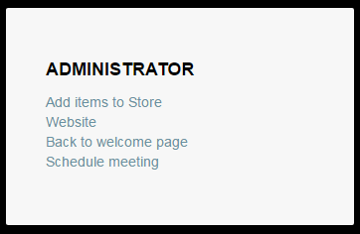

How to schedule a meeting:

The admin can schedule meetings with the club members:

* Input the Date in the *Date* space.
* Input the location of the meeting in the *Location* space.

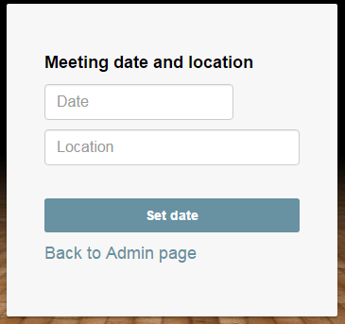

how to add items to the STORE:

The admin can add items to the club’s official store:

* Click on **“Add items to Store”.**
* Input the name of the Item in the *Item* space.
* Set the price of this item in the *Price* space.
* Click “**Set Item”**

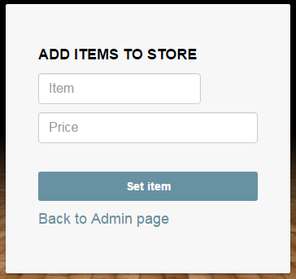

# Guests

The guest can visit the website and check the information of the club.

View Functionnalities:

On the homepage he can view:

* HD live stream link
* Media and downloadable content
* Tour and map

With the help of tabs, the guest can:

* Click on “About Team” tab to view information about the team.
* Click on “Players” tab to view the players of the team and their detailed information.
* Click on “News & Events” tab to view the latest news and events managed by the club.
* Click on “Statistics” tab to view the latest games and club’s stats.
* Click on “Contacts” tab to view the contact information of the club.



Become a member:

The Guest can also register to become a member. On the homepage:

* Click on the Basketball button “Login”.
* Select “Sign up” option.
* Fill in the form and click “Sign up”.

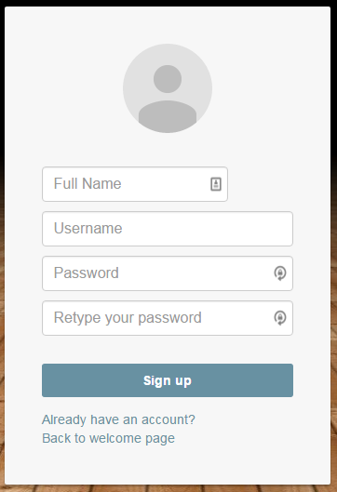

After submitting the form:

* The username is unique to every member so if the username already exists a message will pop up on the screen saying “Username already Exists”.
* If the passwords don’t match a message will pop up on the screen saying “Passwords don’t match”.

To **Cancel** the registration:

* Click on “Already have an account?” button to sign in.
* Click on “Back to welcome page”.

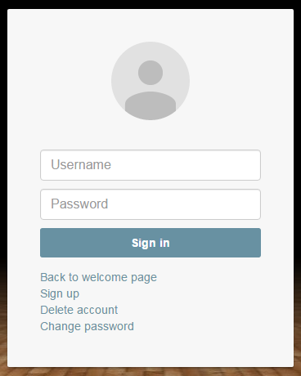

# Members

The member needs to be signed in to have access to all his privileges in the sport club.

sign in:

In the homepage click on “Login”:

* Enter the member’s username in the *username* space.
* Enter the member’s password in the *password* space.

Delete account:

In the login page:

* Click “Delete account”.
* Input username in the *username* space.
* Input password in the *password* space.
* Click “Delete”.

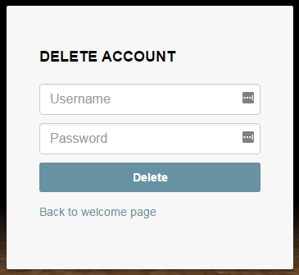

Change password:

In the login page:

* Click “Change Password”.
* Enter username in the *username* space.
* Enter old password in the *old password* space.
* Enter new password in the *new password* space.
* Click “Change”.

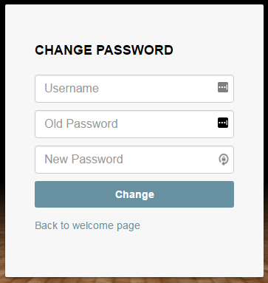

Buy tickets and Donate:

The members can buy tickets and donate money to the club by pressing on the specific field in the homepage.

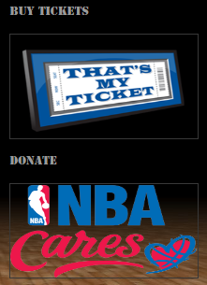

File a complaint:

The members can file a complaint:

* Press on “Contacts” tab.
* Press on “file a complaint”.
* Specify the complaint type.
* Write the message.
* Click “Submit”.

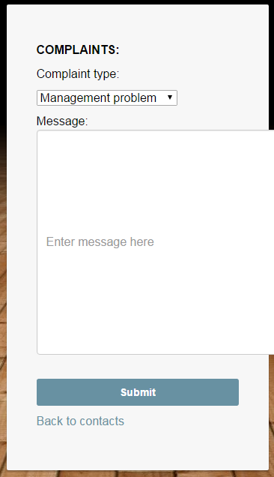

# Players

sign in:

In the homepage select login as a player:

* Input username in *username* space.
* Input password in *password* space.

View funtionalities:

The players can view:

* View squad
* Website
* Training schedule
* View meetings
* Send message to coach

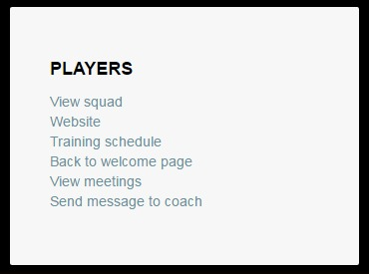

View Meeting Schedule:

In the player’s account, he can check his schedule, which are the appointments requested by the administrator or coach of the club.

From the homepage:

* Click on “View meetings”.

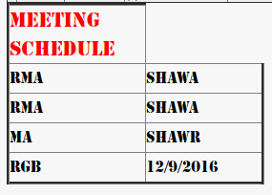

View training schedule:

The players can check the trainings scheduled for this week. From the homepage:

* Click on “Training schedule”.

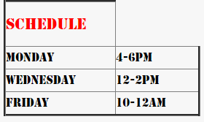

View squad:

The players can check the squad for upcoming games.

From homepage:

* Click on “View squad”.

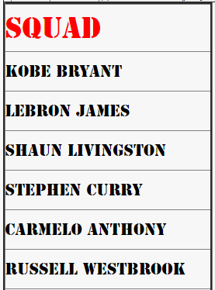

send message to coach:

The players can send a message to the coach.

From the homepage:

* Click “Send message to coach”.
* Enter player name in the *player name* space.
* Enter message
* Click “Send”.

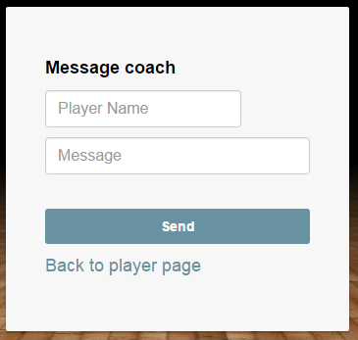

# Coach

Sign in:

In the homepage select login as a coach:

* Input username in *username* space.
* Input password in *password* space.

View coach functionalities:

The coach can view and set:

* Squad for next game
* Set training schedule
* View meetings
* View player’s messages

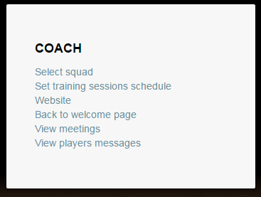

Players selection:

The coach is the only person able to select the players who will feature in the upcoming game.

From homepage:

* Click “Select squad”.
* Fill in the names of the players in the associated fields
* Click “Submit”.

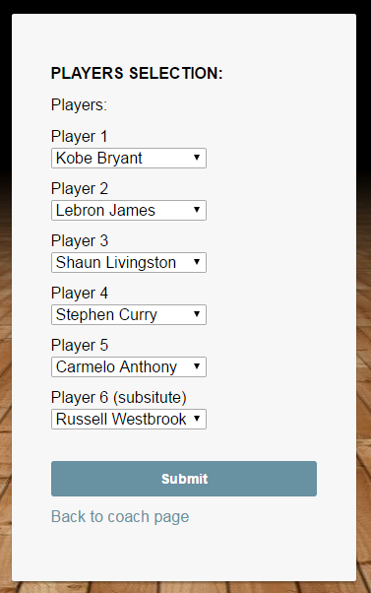

Set training Sessions:

The coach can set the training sessions date and time.

From homepage:

* Click “Set training sessions schedule”.
* Select the time of the training session for every day of the week.
* Click “submit”.

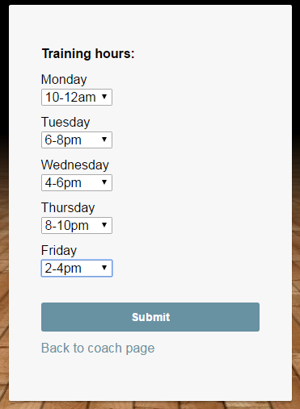

View messages:

The coach is able to view the messages sent by his players.

From homepage:

* Click “View player’s messages”

